***EXERCISE 1 : MOCKING AND STUBBING***

**Scenario:** You need to test a service that depends on an external API. Use Mockito to mock the

external API and stub its methods.

**MyServiceTest.java:**

package com.example;

import static org.mockito.Mockito.*;

import org.junit.jupiter.api.Test;

import static org.junit.jupiter.api.Assertions.*;

public class MyServiceTest {

@Test

public void testExternalApi() {

ExternalApi mockApi = mock(ExternalApi.class);

when(mockApi.getData()).thenReturn("Mock Data");

MyService service = new MyService(mockApi);

String result = service.fetchData();

// Use System.err to force console output

System.out.println("Fetched result: " + result);

assertEquals("Mock Data", result);

}

}

**Pom.xml(Mockito-demo):**

<project xmlns="http://maven.apache.org/POM/4.0.0"

xmlns:xsi="http://www.w3.org/2001/XMLSchema-instance"

xsi:schemaLocation="http://maven.apache.org/POM/4.0.0 http://maven.apache.org/xsd/maven-4.0.0.xsd">

<modelVersion>4.0.0</modelVersion>

<groupId>com.example</groupId>

<artifactId>mockito-demo</artifactId>

<version>1.0-SNAPSHOT</version>

<dependencies>

<dependency>

<groupId>org.junit.jupiter</groupId>

<artifactId>junit-jupiter</artifactId>

<version>5.10.0</version>

<scope>test</scope>

</dependency>

<dependency>

<groupId>org.mockito</groupId>

<artifactId>mockito-core</artifactId>

<version>5.11.0</version>

<scope>test</scope>

</dependency>

</dependencies>

<build>

<plugins>

<plugin>

<groupId>org.apache.maven.plugins</groupId>

<artifactId>maven-surefire-plugin</artifactId>

<version>3.2.5</version>

</plugin>

</plugins>

</build>

</project>

**MyService.java:**

package com.example;

public class MyService {

private final ExternalApi externalApi;

public MyService(ExternalApi externalApi) {

this.externalApi = externalApi;

}

public String fetchData() {

return externalApi.getData();

}

}

**OUPUT:**

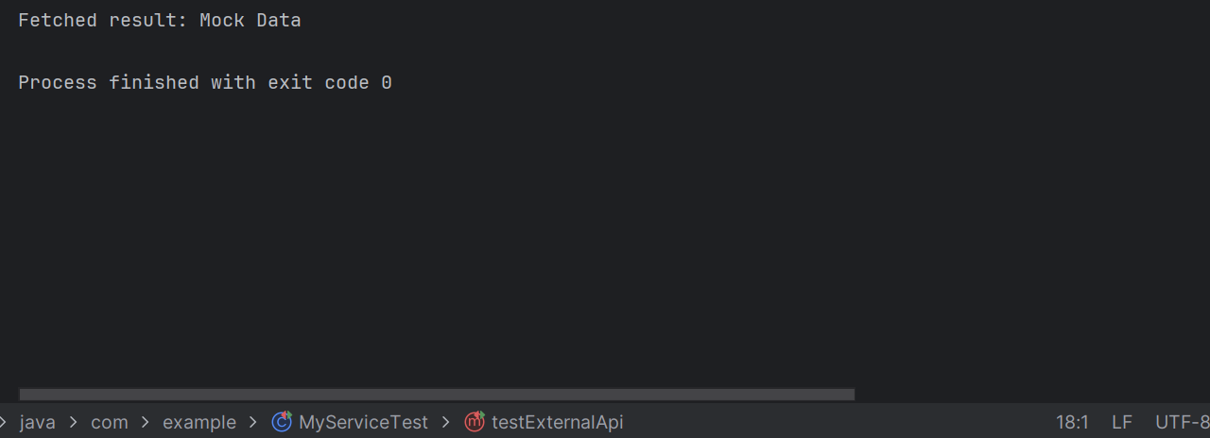

***EXERCISE 2: VERIFYING INTERACTIONS***

**Scenario**: You need to ensure that a method is called with specific arguments.

**MyServiceTest.java:**

package com.example;

import org.junit.jupiter.api.Test;

import static org.mockito.Mockito.*;

public class MyServiceTest {

@Test

public void testVerifyInteraction() {

System.out.println("Starting test for verifying interaction...");

ExternalApi mockApi = mock(ExternalApi.class);

MyService service = new MyService(mockApi);

service.fetchData();

verify(mockApi).getData();

System.out.println("Test finished. Interaction verified.");

}

}

**Pom.xml():**

<project xmlns="http://maven.apache.org/POM/4.0.0"

xmlns:xsi="http://www.w3.org/2001/XMLSchema-instance"

xsi:schemaLocation="http://maven.apache.org/POM/4.0.0 http://maven.apache.org/xsd/maven-4.0.0.xsd">

<modelVersion>4.0.0</modelVersion>

<groupId>com.example</groupId>

<artifactId>MockitoVerifyInteractionExample</artifactId>

<version>1.0-SNAPSHOT</version>

<dependencies>

<dependency>

<groupId>org.junit.jupiter</groupId>

<artifactId>junit-jupiter</artifactId>

<scope>test</scope>

</dependency>

<dependency>

<groupId>org.mockito</groupId>

<artifactId>mockito-core</artifactId>

<version>5.11.0</version>

<scope>test</scope>

</dependency>

<dependency>

<groupId>org.junit.platform</groupId>

<artifactId>junit-platform-launcher</artifactId>

<version>1.10.2</version>

<scope>test</scope>

</dependency>

</dependencies>

<dependencyManagement>

<dependencies>

<dependency>

<groupId>org.junit</groupId>

<artifactId>junit-bom</artifactId>

<version>5.10.2</version>

<type>pom</type>

<scope>import</scope>

</dependency>

</dependencies>

</dependencyManagement>

<build>

<plugins>

<plugin>

<groupId>org.apache.maven.plugins</groupId>

<artifactId>maven-surefire-plugin</artifactId>

<version>3.2.5</version>

</plugin>

</plugins>

</build>

</project>

**MyService.java:**

package com.example;

public class MyService {

private final ExternalApi externalApi;

public MyService(ExternalApi externalApi) {

this.externalApi = externalApi;

}

public void fetchData() {

System.out.println("Calling external API from MyService...");

externalApi.getData();

}

}

**OUPUT:**

